**Que. 1**

**Query a *count* of the number of cities in CITY having a *Population* larger than 1,00,000.**

**Input Format**

**The CITY table is described as follows:**

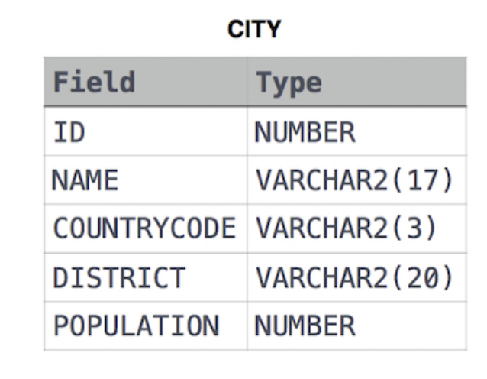

**Solution:**

**Que. 2**

**Query the total population of all cities in CITY where *District* is California.**

**Input Format**

**The CITY table is described as follows:**



**Solution:**

**Que.3**

**Query the average population of all cities in CITY where *District* is California.**

**Input Format**

**The CITY table is described as follows:**

Solution: